36.59: a) For eight slits, the phasor diagrams must have eight vectors:

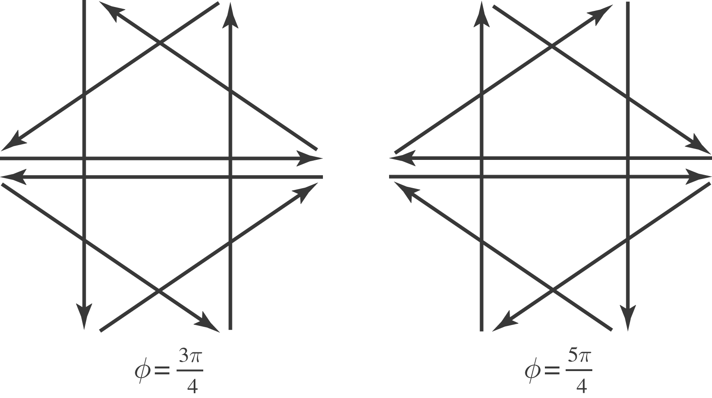

b) For$φ=\frac{3π}{4}, φ=\frac{5π}{4}, \text{and} φ=\frac{7π}{4},$ totally destructive interference occurs between slits four apart. For $φ=\frac{3π}{2},$ totally destructive interference occurs with every second slit.

