36.62: As shown below, a pair of slits whose width and separation are equal is the same as having a single slit, of twice the width.
$φ=\frac{2πd}{λ} \text{sin}θ, \text{so} β=\frac{2πa}{λ} \text{sin} θ=φ\text{.}$
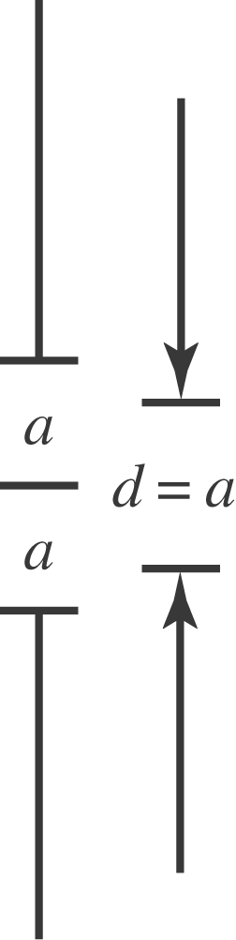

So then the intensity is
$$\begin{aligned}I=I_{0} {\text{cos}}^{2}(β/2) \left(\frac{{\text{sin}}^{2}(β/2)}{(β/2)^{2}}\right)=I_{0}\frac{(2\text{sin}(β/2) \text{cos}(β/2))^{2}}{β^{2}} \\ ⇒ I=I_{0}\frac{{\text{sin}}^{2} β}{β^{2}}=I_{0}\frac{{\text{sin}}^{2}(β^{'}/2)}{(β^{'}/2)^{2}},\end{aligned}$$
$\text{where} β^{'}=\frac{2π(2a)}{λ} \text{sin}θ,$ which is Eq. (35.5) with double the slit width.

