38.55: a) Plot: Below is the graph of frequency versus stopping potential.

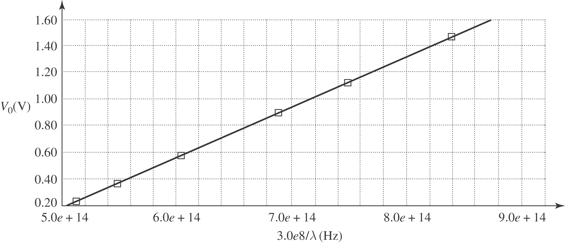

Threshold frequency is when the stopping potential is zero.
$⇒ f_{\text{th}}=\frac{1\text{.}\text{89} }{4\text{.}\text{11}×{\text{10}}^{−\text{15}}} \text{Hz}=4\text{.}\text{60}×{\text{10}}^{\text{14}}\text{ Hz}$
b) Threshold wavelength is $λ_{\text{th}}=\frac{c}{f_{\text{th}}}=\frac{(3\text{.}\text{00}×{\text{10}}^{8} m/s)}{4\text{.}\text{60}×{\text{10}}^{\text{14}} \text{Hz}}=6\text{.}\text{52}×{\text{10}}^{−7} m\text{.}$
c) The work function is just ${\text{hf}}_{\text{th}}=(6\text{.}\text{63}×{\text{10}}^{−\text{34}} J⋅s)(4\text{.}\text{60}×{\text{10}}^{\text{14}}\text{Hz})=3\text{.}\text{05}×{\text{10}}^{−\text{19}} J$
$$=1\text{.}\text{91} \text{eV}\text{.}$$
d) The slope of the graph is $m=\frac{V_{0}}{f}=\frac{h}{e}⇒h=\text{me}$
$$\begin{aligned}=(4\text{.}\text{11}×{\text{10}}^{−\text{15}} V/\text{Hz})(1\text{.}\text{60}×{\text{10}}^{−\text{19}} C) \\ 6\text{.}\text{58}×{\text{10}}^{−\text{34}} J⋅s\end{aligned}$$

