38.62: a) The levels are $E_{4}=−1\text{.}0 \text{eV,} E_{3}=−5\text{.}0 \text{eV,} E_{2}=−8\text{.}0 \text{eV,} \text{and} E_{1}=−\text{10}\text{.}0 \text{eV}\text{.}$

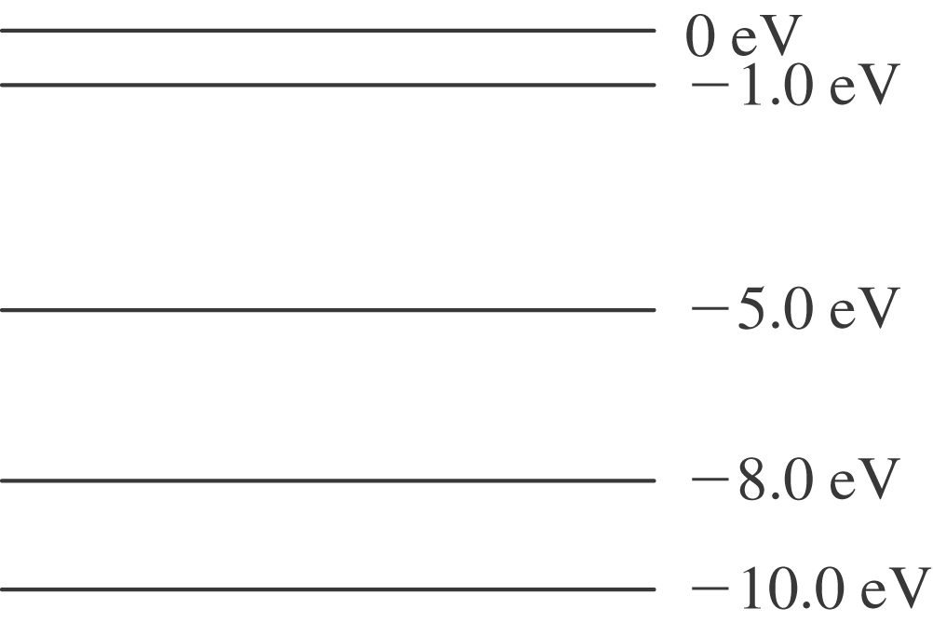

b) We can go from 4-3(4 eV), 4-2(7 eV), and 4-1(9 eV) directly, but also 3-2(3 eV),
3-1(5 eV), and 2-1(2 eV) after starting from 4.

