39.67: a) $ψ(x)=\int{{B(k)\text{cos} \text{kxdk}=\int{(\frac{1}{k_{0}}) \text{cos}\text{kxdk}=\frac{\text{sin} \text{kx}}{k_{0}x}|}}_{0}^{k_{0}}}=\frac{\text{sin} k_{0}x}{k_{0}x}$
b) $ψ(x)$ has a maximum value at the origin $x=0\text{.} ψ(x_{0})=0 \text{when} k_{0}x_{0}=π \text{so} x_{0}=\frac{π}{k_{0}}\text{.}$Thus the width of this function $w_{x}=2x_{0}=\frac{2π}{k_{0}}\text{.}$
If $k_{0}=\frac{2π}{L},w_{x}=L\text{.}$
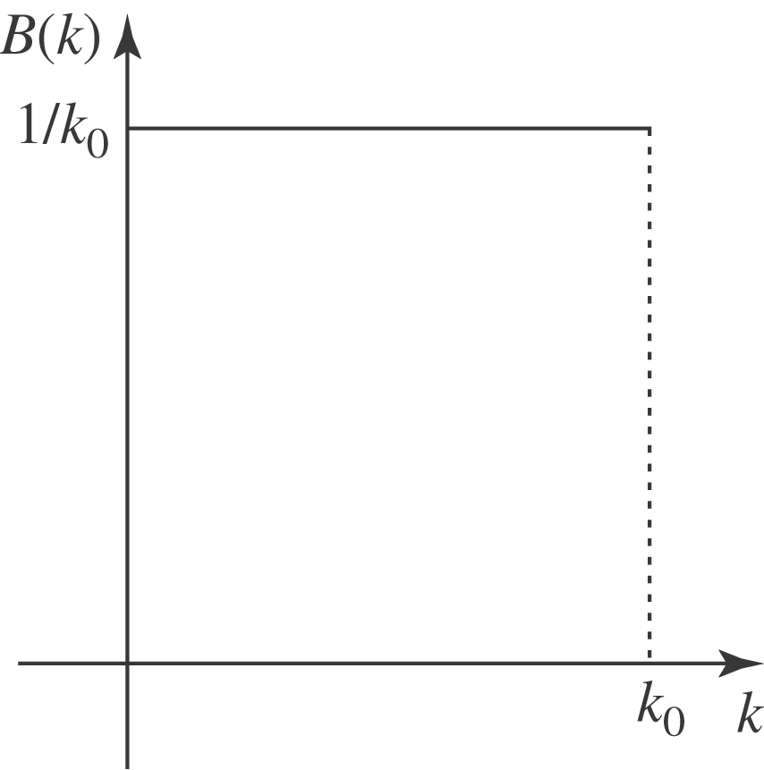
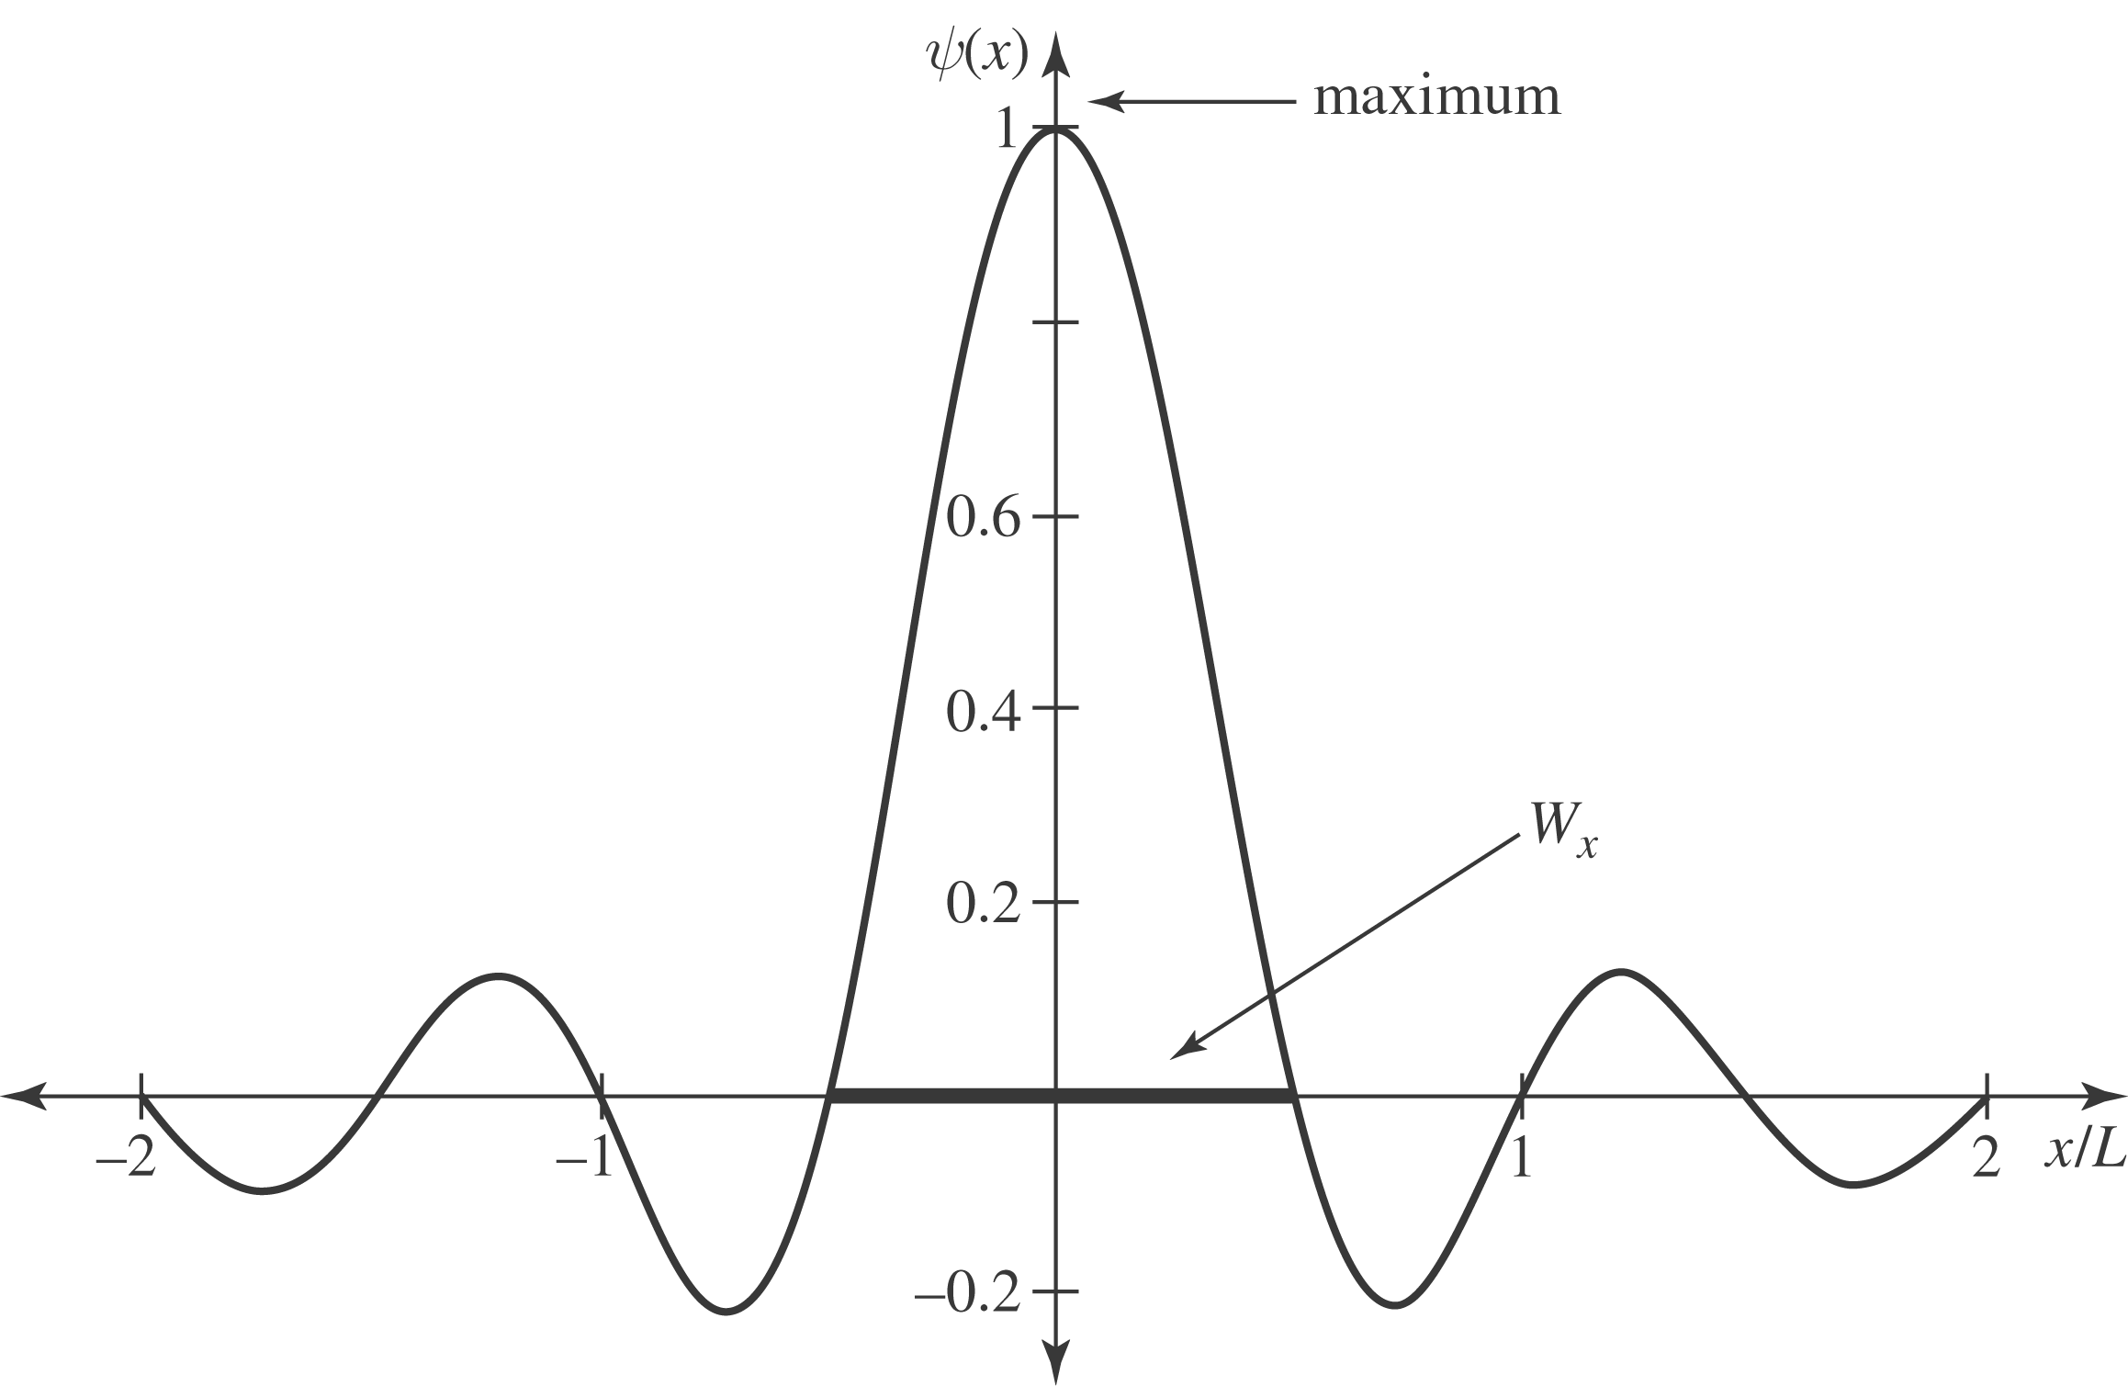
c) If $k_{0}=\frac{π}{L}w_{x}=2L\text{.}$
d) $w_{p}w_{x}=\left(\frac{{\text{hw}}_{k}}{2π}\right) \left(\frac{2π}{k_{0}}\right)=\frac{{\text{hw}}_{k}}{k_{0}}=\frac{{\text{hk}}_{0}}{k_{0}}=h\text{.}$
The uncertainty principle states that $w_{p}w_{x}≥\frac{h}{2π}\text{.}$ For us, no matter what $k_{0} \text{is}, w_{p}w_{x}=h,$which is greater than $\frac{h}{2π}\text{.}$

