40.43: a) For a free particle, $U(x)=0$ so $\text{Schr \{}\overset{¨}{o}\text{dinger's} \text{equation} \text{becomes} \frac{d^{2}ψ(x)}{{\text{dx}}^{2}}=$
$$−\frac{2m}{h^{2}}\text{Eψ}(x)\text{.}$$
See graph below.
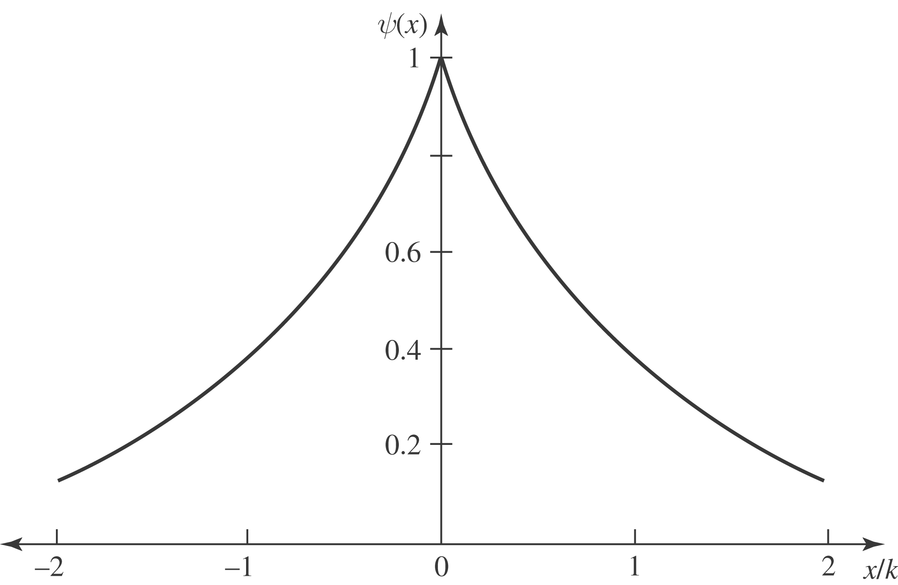

b) For x < 0$ψ(x)=e^{+\text{kx}}\text{.}$
$\begin{aligned}\frac{\text{dψ}(x)}{\text{dx}}={\text{ke}}^{+kx}\text{.} \\ \frac{d^{2}ψ(x)}{\text{dx}}=k^{2}e^{+kx}\text{.}\end{aligned}$
So $k^{2}=−\frac{2m}{ℏ^{2}}E ⇒ E=−\frac{ℏ^{2}k^{2}}{2m}\text{.}$
c) For x > 0 $ψ(x)=e^{−\text{kx}}\text{.}$
$\frac{\text{dψ}(x)}{\text{dx}}=−{\text{ke}}^{−\text{kx}}\text{.}$
$\frac{d^{2}ψ(x)}{\text{dx}}=k^{2}e^{−\text{kx}}$
So again $k^{2}=−\frac{2m}{ℏ^{2}}E ⇒ E=\frac{−ℏ^{2}k^{2}}{2m}\text{.}$
Parts (c) and (d) show $ψ(x)$ satisfies equation, provided $E=\frac{−ℏ^{2}k^{2}}{2m}\text{.}$
d) Note $\frac{\text{dψ}(x)}{\text{dx}}$ is discontinuous at $x=0\text{.} (\text{That} \text{is,} \text{negative} \text{for} x > 0 \text{and} \text{positive} \text{for} x < 0\text{.})$

