43.77: (a) There are two processes occurring: the creation of ${}^{\text{128}}I$ by the neutron irradiation, and they decay of the newly produced ${}^{\text{128}}I$. So $\frac{\text{dN}}{\text{dt}}=K−λN \text{where} K$ is the rate of production by the neutron irradiation. Then $\int{\frac{dN^{'}}{K−λN^{'}}=\int{\text{dt}\text{.}}}$
$\begin{aligned}⇒{\left[\text{ln}\left(K−λN^{'}\right)\right]}_{0}^{N}=−λt \\ ⇒\text{ln}\left(K−λN\right)=\text{ln} K−λt \\ ⇒N\left(t\right)=\frac{K\left(1−e^{−λt}\right)}{λ}\text{.}\end{aligned}$
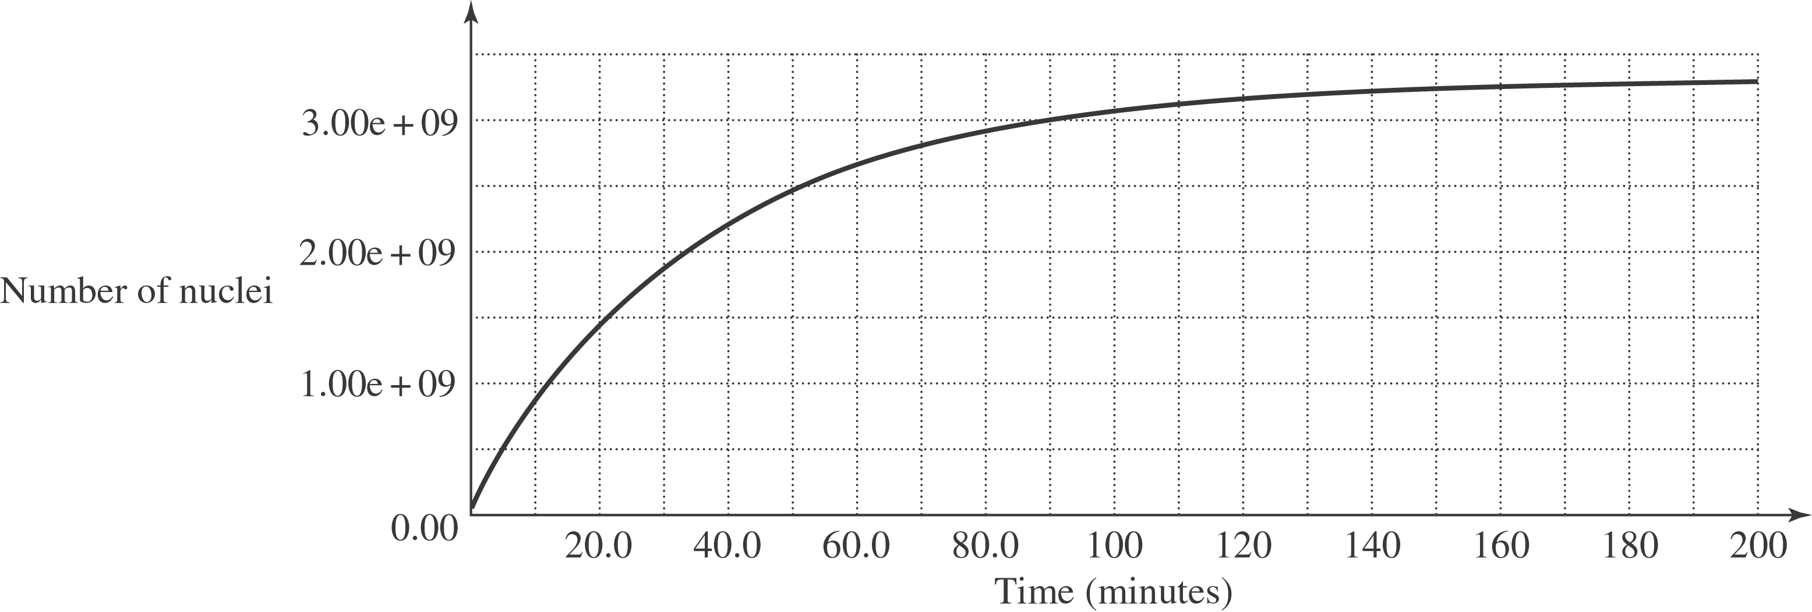

b) The activity of the sample is $λN\left(t\right)=K\left(1−e^{−λt}\right)=\left(1\text{.}5×{\text{10}}^{6} \text{decays}/s\right)×$
$\left(1−e^{−\left(\frac{0\text{.}\text{693}}{\text{25} \text{min}}\right)t}\right)$. So the activity is $\left(1\text{.}5×{\text{10}}^{6} \text{decays}/s\right) \left(1−e^{−0\text{.}\text{02772} t}\right)$, with t in minutes. So the activity $\left(\frac{−dN^{'}}{\text{dt}}\right)$ at various times is:
$\begin{aligned}\frac{−dN^{'}}{\text{dt}}(t=1 \text{min})=4\text{.}1×{\text{10}}^{4} \text{Bq;} \frac{−dN^{'} (t=\text{10} \text{min})}{\text{dt}}=3\text{.}6×{\text{10}}^{5} \text{Bq;} \\ \frac{−dN^{'}}{\text{dt}}(t=\text{25} \text{min})=7\text{.}5×{\text{10}}^{5} \text{Bq;} \frac{−dN^{'} (t=\text{50} \text{min})}{\text{dt}}=1\text{.}1×{\text{10}}^{6} \text{Bq;} \\ \frac{−dN^{'}}{\text{dt}}(t=\text{75} \text{min})=1\text{.}3×{\text{10}}^{6} \text{Bq;} \frac{−dN^{'} (t=\text{180} \text{min})}{\text{dt}}=1\text{.}5×{\text{10}}^{6} \text{Bq;}\end{aligned}$
c) $N_{\text{max}}=\frac{K}{λ}=\frac{(1\text{.}5×{\text{10}}^{6}) (\text{60})}{\left(0\text{.}\text{02772}\right)}=3\text{.}2×{\text{10}}^{9} \text{atoms}$.
d) The maximum activity is at saturation, when the rate being produced equals that decaying and so it equals $1\text{.}5×{\text{10}}^{6} \text{decays}/s\text{.}$

